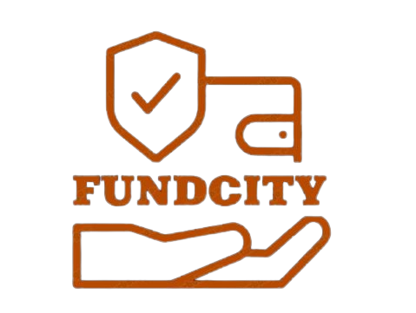

Köpenicker Str. 18-20,1

**Berlin, Germany**

**10997**

**enquiry@fundcity.eu**

**Fundcity**

Recovery Agreement

Hereby, we at Fundcity**(Company)** undertake to transfer funds lost during investment activity with the fraudulent financial institution to Mr/Mrs

(**Customer**) during the Customer Financial Protection Process. Recovered funds are coming from the confirmed fraudulent investment institution as the result of completed dispute case #322-1489AF.

Recovery agreement contains two main parties: **Customer** and **Company**. By signing this agreement both parties undertake to execute their obligations in terms described below.

**Company**’s duty and interest:

1. **Company** obliges to guide and support **Customer** throughout the recovery process.
2. **Company** does not provide complete guarantee on the successful finish of the recovery process in case **Customer** violates the Recovery Agreement.
3. **Company** undertakes to restore **Customer** investment loss in case of proven guilty of the financial institution where the **Customer**’s investment took place.
4. **Company** does not take any responsibility for the legal fees/charges/commission/deductions that can be requested by the third- party involved in the recovery process (Bank/ Tax Office/ Exchange platforms etc…).

**Customer**’s duty and interest:

* 1. **Customer** obliges to verify his/her identity upon the request of case coordinator.
  2. **Customer** undertakes to not disclose any details regarding the recovery process to the third-parties until the complete finish of the recovery process.
  3. **Customer** confirms that he/she’s provided with all the necessary information about the possible charges that can be requested by the mediatory third-party uncontrolled by the **Company**.
  4. **Customer** hereby confirms that the funds previously invested to the fraudulent investment institution are not violating AML and Tax Evasion policies.

**Company** will provide a personal coordinator to each recovery case. Case coordinator duty is to guide and support the **Customer** through the recovery process until it’s complete finalization.

**Customer** undertakes to follow the instruction provided by the case coordinator and keep the communication with responsible person until the fact of receiving restored funds and paying the **Company** interest.

Chief Recovery Officer

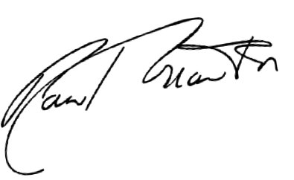

Chief Recovery Officer Mr Paul Beauchlen

Mr. Paul Beauchlen



______________________________________



Customer’s name: ____________________________

Customer’s signature: ____________________ Date: 08/11/2024

